
Insert Practice Address:
Insert Phone Number:
Insert Date:

Dear …(patient name)
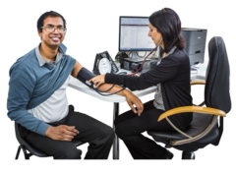 | Please come for your  Annual Health Check appointment
Insert picture of health centre | This will be at … (Health Centre)
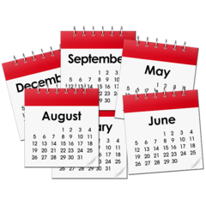 | insert day and date  Day:  Date:
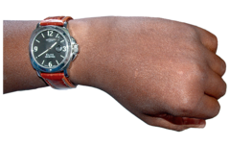 | Time: … insert time
 | Please bring your Health Action Plan
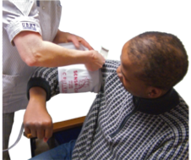  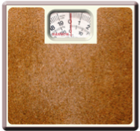    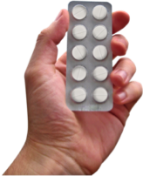 | We will talk about things like;  - your health  - check your weight  - check blood pressure  - talk about tablets
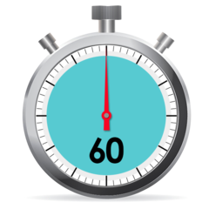 | This might take up to 60 minutes
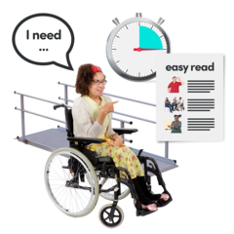 | Please tell us if you need special help to attend  (called reasonable adjustments)
  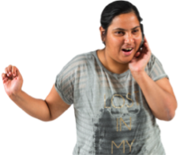 | Please phone us if you cannot come on that date  ….insert phone number

From your GP/Practice Nurse: Insert name

